LAB EXPERIMENT RECORD
Set 19: Survey Responses Analysis

Department | AIML
Course Code / Course Name | DSA0601 / Data Handling and Visualization
Experiment | Data Visualization using R
Name | G. Ganga Chandrika
Register Number | 1925260144
Date | 15 October 2026
Day | Thursday

Aim
To analyse survey responses by creating a grouped bar chart for Question 1, a stacked bar chart for all three questions, and a formatted response table using R (ggplot2), and to combine them into a single dashboard for exploring the survey responses.
Dataset: Survey Responses
Survey ID | Question 1 | Question 2 | Question 3
1 | A | B | C
2 | B | A | D
3 | C | A | B

PROGRAM 1: Grouped Bar Chart for Question 1
Create a grouped bar chart to visualize the distribution of answers for Question 1. Label the chart elements.
# Create the survey dataset
survey <- data.frame(
Survey_ID = c(1, 2, 3),
Question_1 = c("A", "B", "C"),
Question_2 = c("B", "A", "A"),
Question_3 = c("C", "D", "B")
)
# Display the dataset
print(survey)
library(ggplot2)
q1_data <- as.data.frame(table(survey$Question_1))
colnames(q1_data) <- c("Answer", "Count")
ggplot(q1_data, aes(x = Answer, y = Count, fill = Answer)) +
geom_bar(stat = "identity") +
labs(
title = "Distribution of Answers for Question 1",
x = "Answer",
y = "Number of Responses"
) +
theme_minimal()
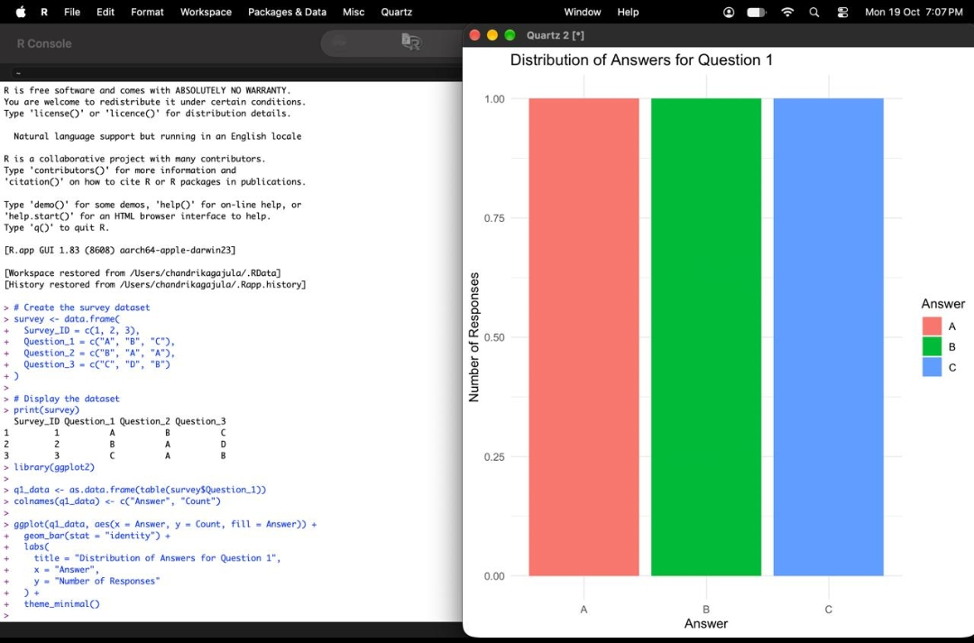
Output 1: Distribution of Answers for Question 1
Observation: Answers A, B and C each received exactly one response for Question 1, so all three bars have the same height. Answer D was not selected by any respondent.

PROGRAM 2: Stacked Bar Chart for All Questions
Generate a stacked bar chart to represent the overall distribution of responses for all three questions.
library(tidyr)
long_data <- pivot_longer(
survey,
cols = c(Question_1, Question_2, Question_3),
names_to = "Question",
values_to = "Answer"
)
ggplot(long_data, aes(x = Question, fill = Answer)) +
geom_bar() +
labs(
title = "Overall Distribution of Survey Responses",
x = "Questions",
y = "Number of Responses",
fill = "Answer"
) +
theme_minimal()
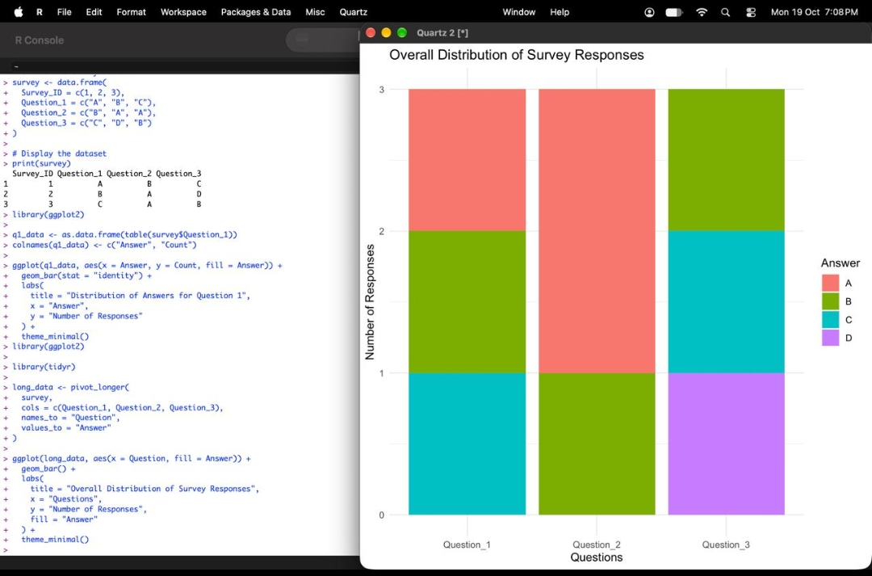
Output 2: Overall Distribution of Survey Responses
Observation: Each bar contains three responses. Answer A appears twice in Question 2 (the tallest segment), while Question 1 and Question 3 are made up of three different answers each. Across all questions, A and B were chosen 3 times each, C twice, and D once.

PROGRAM 3: Table of Survey Response Data
Build a table to show the survey response data for each survey. Label the table elements.
# Create a formatted table
knitr::kable(
survey,
caption = "Survey Response Data",
col.names = c(
"Survey ID",
"Question 1",
"Question 2",
"Question 3"
)
)
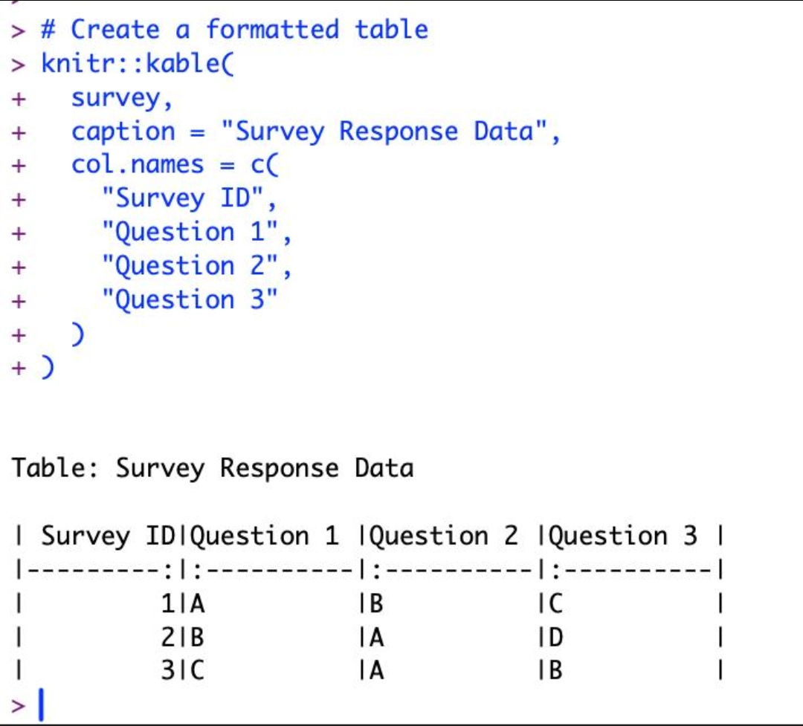
Output 3: Survey Response Data Table (R Console Output)
Table: Survey Response Data
Survey ID | Question 1 | Question 2 | Question 3
1 | A | B | C
2 | B | A | D
3 | C | A | B

Observation: The table lists the answer given by each survey respondent for Questions 1 to 3, with labelled columns and a caption.

PROGRAM 4: Survey Responses Analysis Dashboard
Develop a dashboard combining the grouped bar chart, stacked bar chart, and the table for exploration of survey responses.
# Install these packages once if needed
# install.packages("ggplot2")
# install.packages("tidyr")
# install.packages("gridExtra")
library(ggplot2)
library(tidyr)
library(gridExtra)
library(grid)
# Chart 1: Question 1 distribution
p1 <- ggplot(q1_data, aes(x = Answer, y = Count, fill = Answer)) +
geom_bar(stat = "identity") +
labs(title = "Question 1 Distribution",
x = "Answer", y = "Count") +
theme_minimal()
# Chart 2: Stacked distribution
p2 <- ggplot(long_data, aes(x = Question, fill = Answer)) +
geom_bar() +
labs(title = "All Questions Distribution",
x = "Question", y = "Count") +
theme_minimal()
# Table
table_plot <- tableGrob(survey)
# Combine charts and table
grid.arrange(
p1, p2, table_plot,
ncol = 2,
top = "Survey Responses Analysis Dashboard"
)
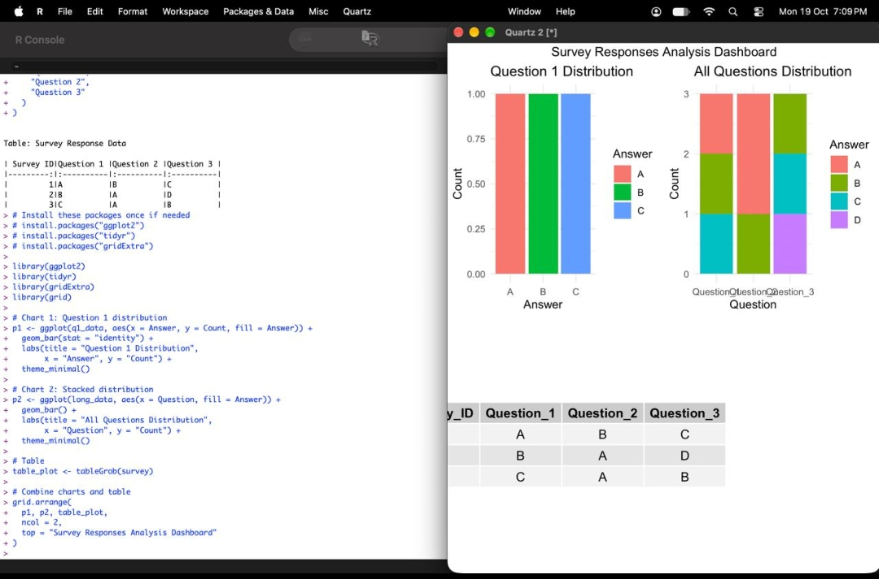
Output 4: Survey Responses Analysis Dashboard
Observation: The dashboard places the Question 1 grouped bar chart, the all-questions stacked bar chart and the survey response table on one page, so the individual answers and the overall distribution can be compared together.

Procedure
1. Create the survey data frame with Survey_ID, Question_1, Question_2 and Question_3, and display it with print().
2. Load ggplot2, count the answers of Question 1 using table(), and plot them with geom_bar(stat = "identity") using title, axis labels and colour fill.
3. Load tidyr and convert the data to long format using pivot_longer() so that all three questions are in one column.
4. Plot the long data with geom_bar() using Question on the x-axis and fill = Answer to produce the stacked bar chart.
5. Use knitr::kable() with a caption and col.names to produce the labelled survey response table.
6. Load gridExtra, convert the survey data to a table with tableGrob(), and combine both charts and the table using grid.arrange() to form the dashboard.
7. In Tableau: connect to the survey data, pivot Question 1 to 3 into rows, build the grouped and stacked bar sheets and the table sheet, then combine them in a dashboard and add the Answer filter for interactive exploration.
Result
The survey responses were successfully analysed. A bar chart for Question 1, a stacked bar chart for all three questions, and a labelled response table were created in R, and all three were combined into a single Survey Responses Analysis Dashboard.
Key R Functions Used
Function | Purpose
data.frame() | Creates the survey dataset.
table() | Counts the number of responses for each answer.
ggplot() | Creates the base plot for the charts.
geom_bar() | Draws grouped and stacked bars.
labs() | Adds the title, axis labels and legend label.
theme_minimal() | Applies a clean chart theme.
pivot_longer() | Reshapes the questions into long format.
knitr::kable() | Builds the labelled response table.
tableGrob() | Converts the data frame into a table graphic.
grid.arrange() | Combines charts and table into one dashboard.

